**CIS 375 – Fall 2019 Term Project - BRAINS**



Use Case Specification Document

**3**

**Question Maintenance**

**Version No. 1.2.0**

**Project Document Revision History**

|  |  |  |  |
| --- | --- | --- | --- |
| **VersionNumber** | **Date** | **Revision Author** | **Description of Revision** |
| 1.0.0 | 10/28/2019 | Mostafa ELMajzoub | Creation of document. |
| 1.1.0 | 10/30/2019 | Mostafa ELMajzoub | Updated use case diagram |
| 1.2.0 | 12/13/2019 | Muaz Alhaidar | Removed Helped button feature |

# 

|  |
| --- |
| **Table of Contents** |

1. Introduction 4

2. Use Case Information 4

2.1 Actors 4

2.2 Use Case Interaction 4

3. Trigger 4

4. Pre-condition(s) 4

4.1 Department users has already been created to answer the questions 4

5. Post-condition(s) 5

5.1 Questions are modified 5

5.2 Questions are added 5

5.3 Questions are removed 5

6. Use Case Swimlane (Activity) Diagram 5

7. Main/Basic Flow(s) of Events (Happy Path) 6

7.1 Question is removed 6

7.2 Question is added 6

7.3 Question is modified 6

8. Alternate/Exception Flow of Events 6

9. Assumptions/Business Rules including Non-Functional Requirements 6

10. Use Case Specification Review and Signoff 7

# Introduction

Write a single paragraph describing the purpose of the specific use case in the Introduction.

This use case is for adding, removing, or modification of questions done by the Oversight Team. The questions get sent to Departments for answering. This is Use Case 3, with the Oversight Team as the main actor and the Departments as the secondary actor.

# Use Case Information

## Actors

An actor is someone or something (e.g. application system) outside the system or business that interacts with the application. For every Use Case, there must be at least one Main Actor and zero or more Secondary Actors. Actors should be a person, system, or time.

|  |  |  |
| --- | --- | --- |
| Actor Name | Role | Description |
| Oversight Team | Main | Can Create, remove, update, and modify the questions. |
| Database | Secondary | The Database stores any changes that are added, modified, or removed to the questions. |

## Use Case Interaction

How does this use case relate to other uses cases? List predecessor and successor use cases.

Predecessors:

1. Use case 5: ~
   1. Users are created to answer the questions and modify them as needed.

Successors:

1. Use case 1: ~
   1. Departments answer the questions
2. Use case 4: ~
   1. Questions can be updated and reviewed by the oversight team.
   2. Then they determine if they reject or approve the submissions

# Trigger

What causes the use case to initiate?

Oversight user decides to remove/add/modify questions on a STENER.

# Pre-condition(s)

What use cases or other pre-conditions must be met before use can initiate?

## User must be logged in as an oversight user to edit questions

## Oversight user must go into Update STENER Functionality to access this use case

# Post-condition(s)

What are ALL the possible output states upon completion of the use case flows?

## Questions are modified

## Questions are added

## Questions are removed

# Use Case Swimlane (Activity) Diagram

Draw diagram(s) that cover ALL main and alternate flows.

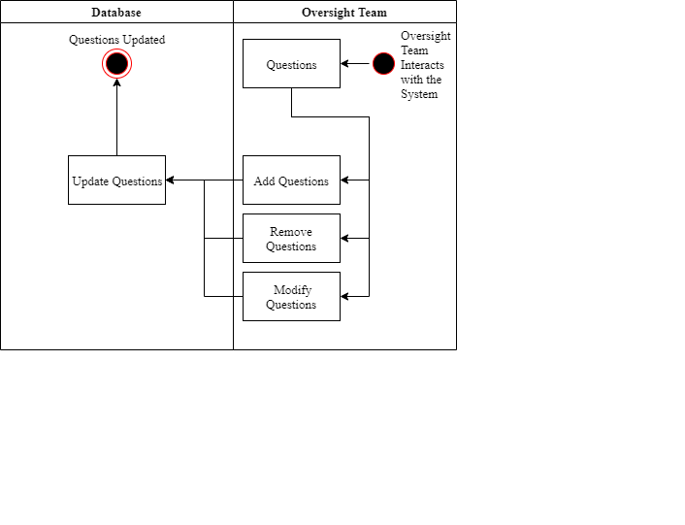

# Main/Basic Flow(s) of Events (Happy Path)

For each main flow (usually ONE flow) write the list of steps that occur – describe WHAT occurs not HOW to do it!

## Question is removed

* An Oversight team user interacts with the system
* Oversight user removes questions
* Database updates questions

## Question is added

* An Oversight team user interacts with the system
* Oversight user adds questions
* Database updates questions

## Question is modified

* An Oversight team user interacts with the system
* Oversight user modifies questions
* Database updates questions

# Alternate/Exception Flow of Events

For each alternative flow (can be zero or more) write the list of steps that occur – describe WHAT occurs not HOW to do it!

# Assumptions/Business Rules including Non-Functional Requirements

Be sure to number the assumption/business rules to allow easy reference to them. Business rules will be where non-functional requirements are recorded – have a way to specifically identify non-functional requirements.

# Use Case Specification Review and Signoff

|  |  |  |  |
| --- | --- | --- | --- |
| Review and Signoff of the Use Case Specification | | | |
| Name | Project Team Role | Signature | Date |
| Ahmed, Zakariya | Senior Tech Lead/SPMP manager | Z.A. | 12/13/19 |
| Alhaidar, Muaz | Developer | M.A. | 12/13/19 |
| Longworth, Kevin | Developer | K.L. | 12/13/19 |
| Labut, Cameron | Developer | C.L. | 12/13/19 |
| Majzoub, Mostafa El | Developer | M.M. | 12/13/19 |